Eshetu Wekjira

Lab 07- Adder/Subtractor

**Task 1: 1-bit Full Adder**

B) **Truth Table**

|  |  |  |  |  |
| --- | --- | --- | --- | --- |
| A | B | Cin | Sum | Cout |
| 0 | 0 | 0 | 0 | 0 |
| 0 | 0 | 1 | 1 | 0 |
| 0 | 1 | 0 | 1 | 0 |
| 0 | 1 | 1 | 0 | 1 |
| 1 | 0 | 0 | 1 | 0 |
| 1 | 0 | 1 | 0 | 1 |
| 1 | 1 | 0 | 0 | 1 |
| 1 | 1 | 1 | 1 | 1 |

**C) Sum of products**

Sum = **A’B’Cin + A’BCin’ + AB’Cin’ +ABCin**

Cout = A**’BCin +AB’Cin +ABCin’ +ABCin**

To find the sum of the product just by the sum of all the values of output 1. In this case, the output is (sum and Cout).

**D) K-Map for Sum**

|  |  |  |  |  |
| --- | --- | --- | --- | --- |
| BCin  A | 00 | 01 | 11 | 10 |
| 0 | 0 | 1 | 0 | 1 |
| 1 | 1 | 0 | 1 | 0 |

We can’t minimize the sum values of the k-map

Sum = **A’B’Cin + A’BCin’ + AB’Cin’ +ABCin**

**K- Map for Cout**

|  |  |  |  |  |
| --- | --- | --- | --- | --- |
| BCin  A | 00 | 01 | 11 | 10 |
| 0 | 0 | 0 | 1 | 0 |
| 1 | 0 | 1 | 1 | 1 |

Cout = **AB + BCin+ ACin**



**E, F) Implement a Full adder**

After I found the truth tables for the Sum and Cout, I tried to use different gates to see the result that much with sum or Cout, and after trying and error; I got the three circuit gates that gave the correct output that much my truth tables for Sum and Cout.

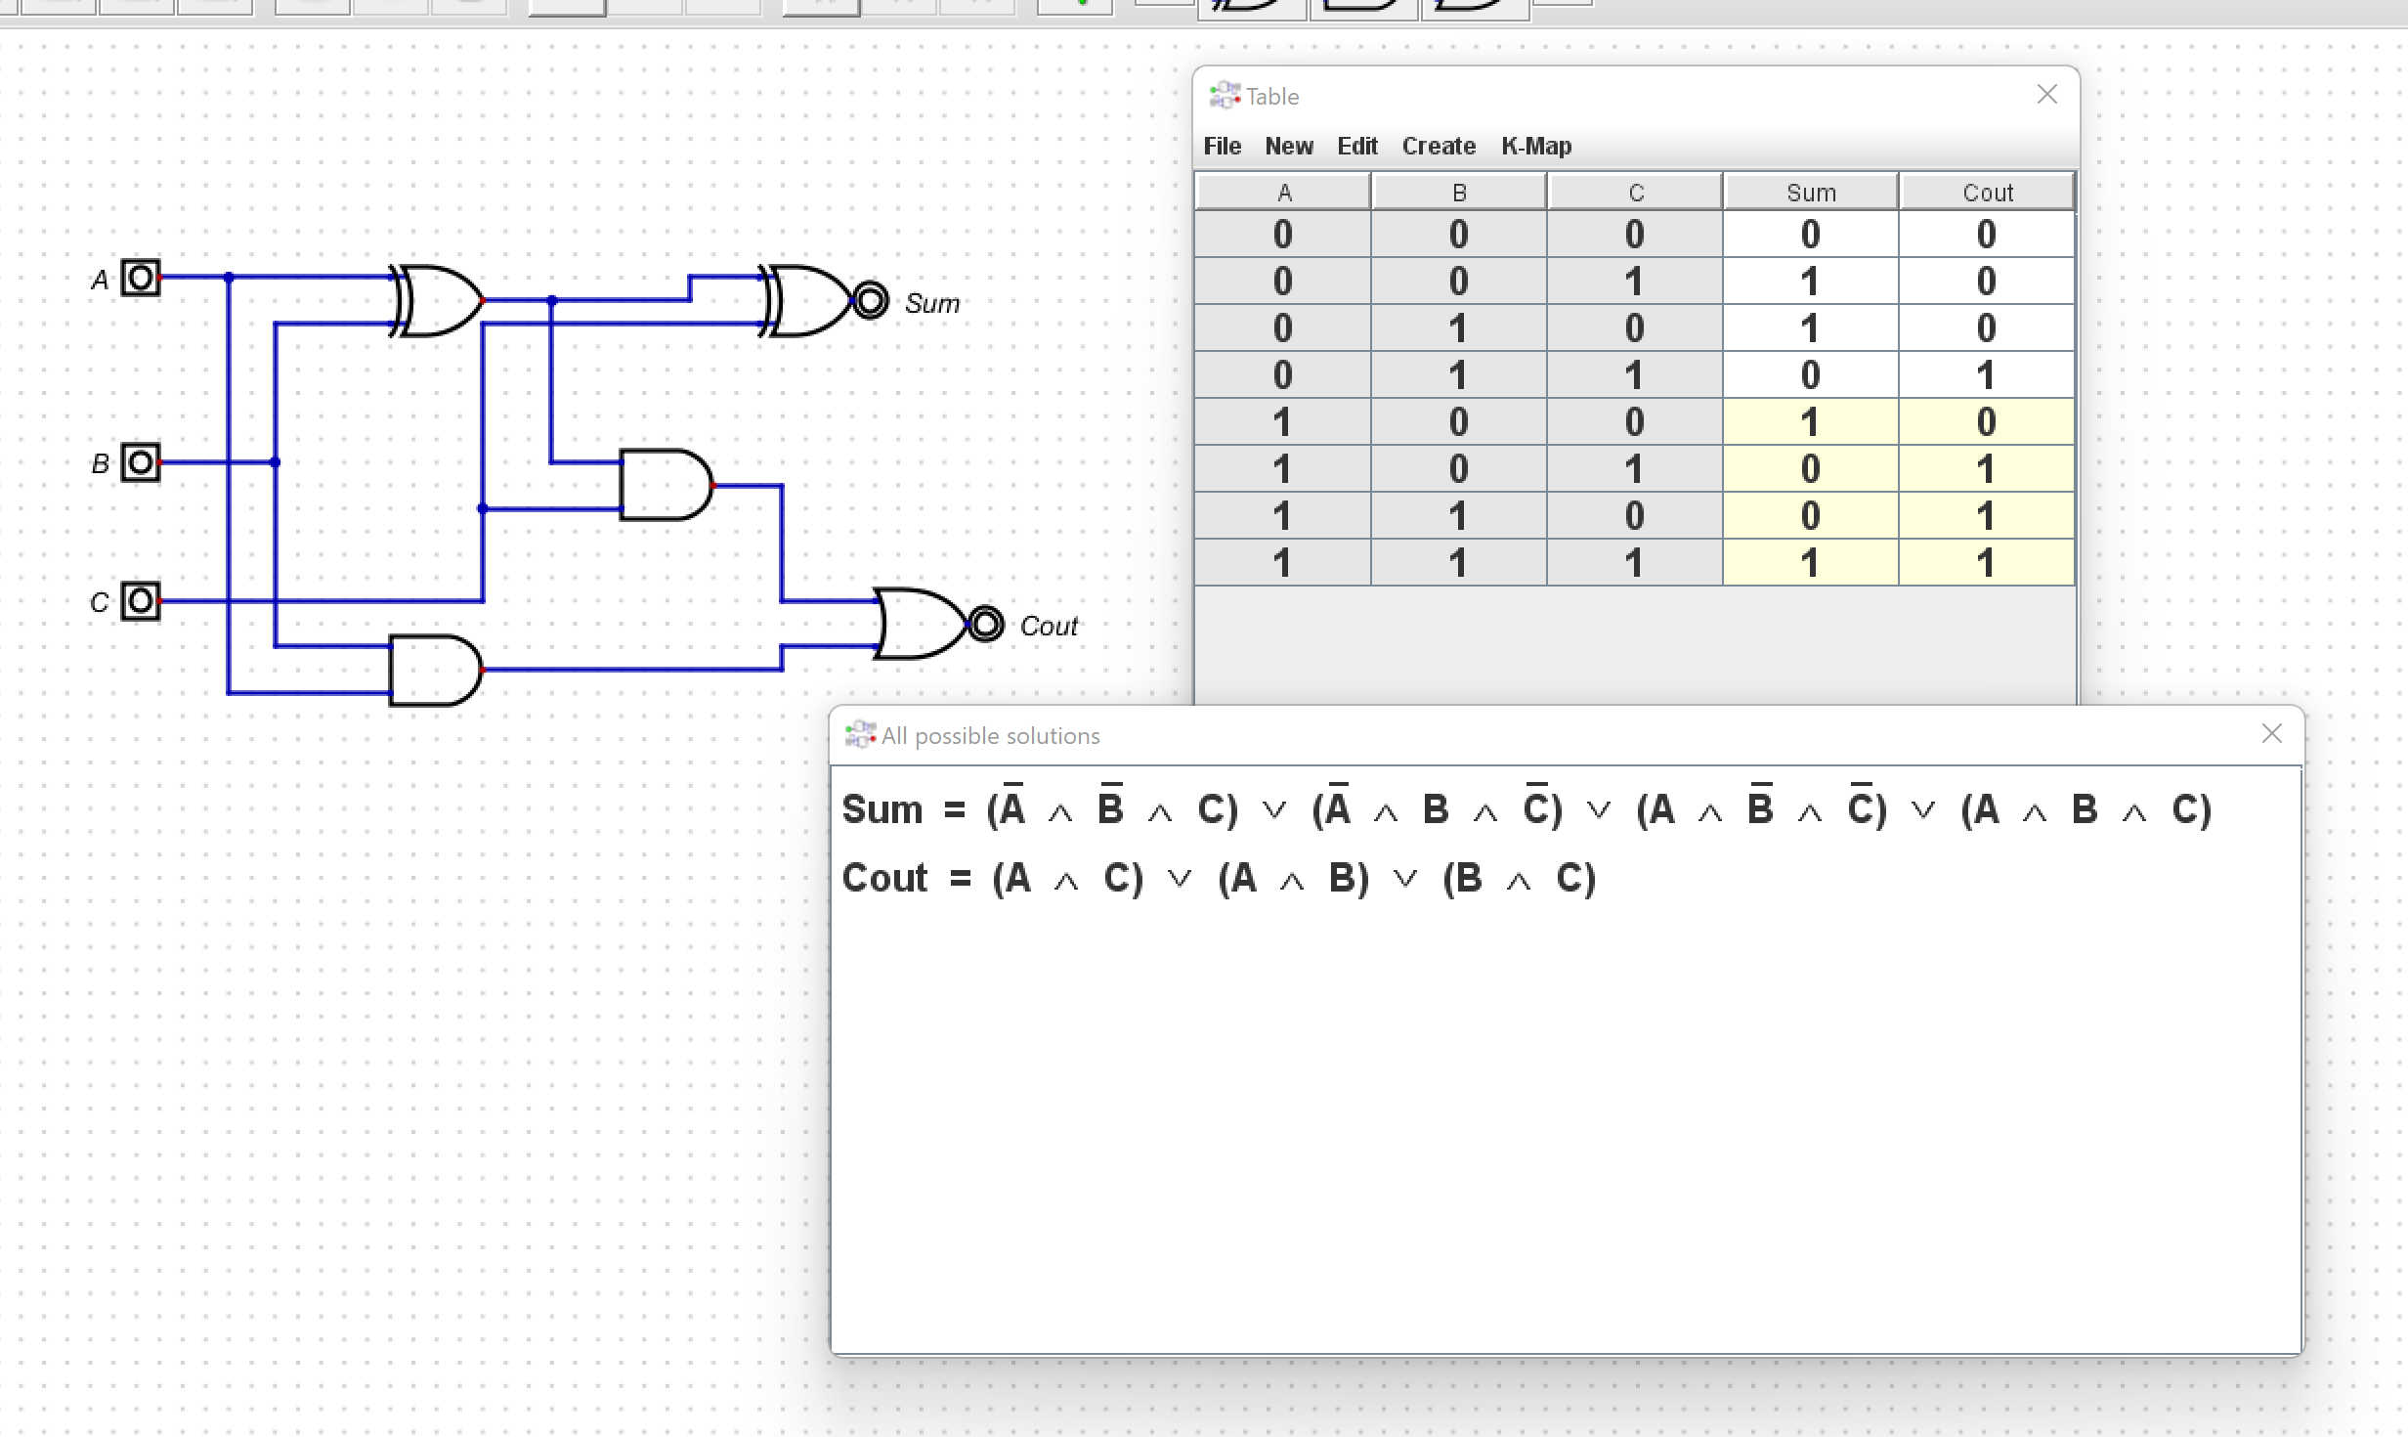

**Figure 1: The digital schematic for the adder**

The test result for the **Sum** schematic

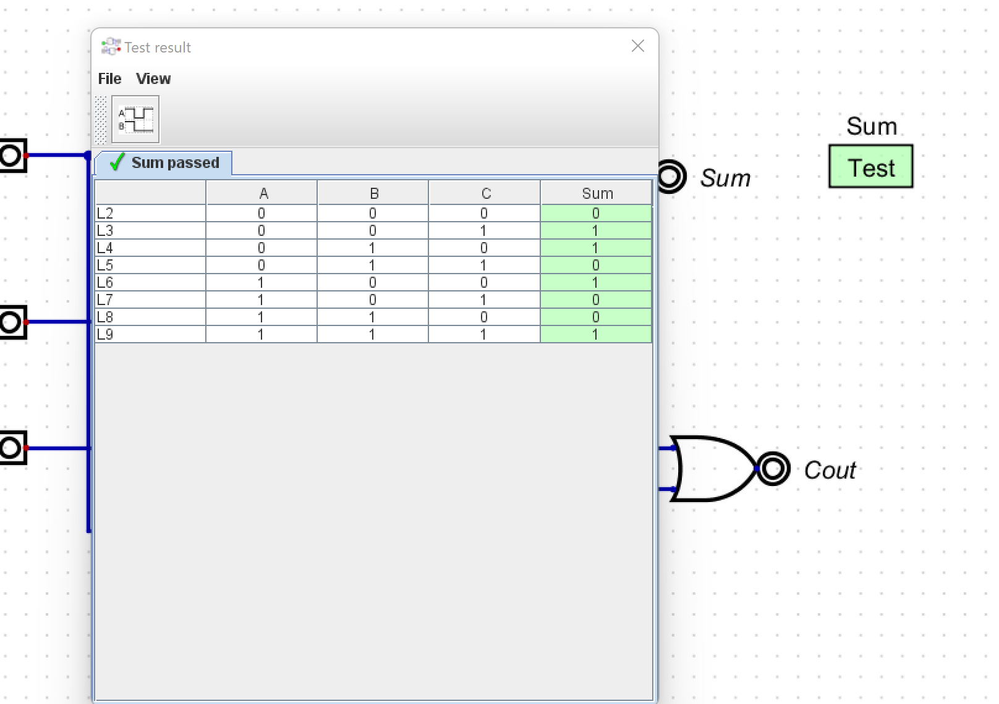

Figure 2: test result of the sum schematic

The test result for the **Cout** schematic

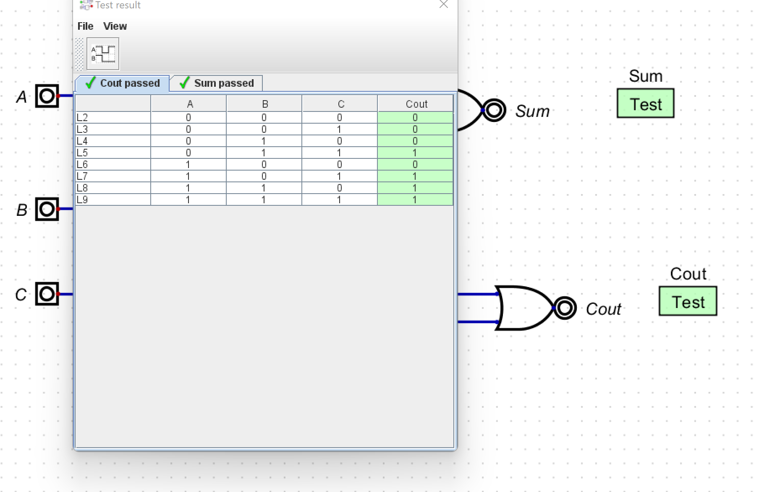

Figure 3: test result of the Cout schematic

**Task 2: Adder/Subtractor**

In this case, we have three inputs and two outputs, such as the sum and Cout; in this case, the Cout is the previous borrow value and is not a carryout. We must borrow values to subtract one or more from zeros in a subtractor circuit.

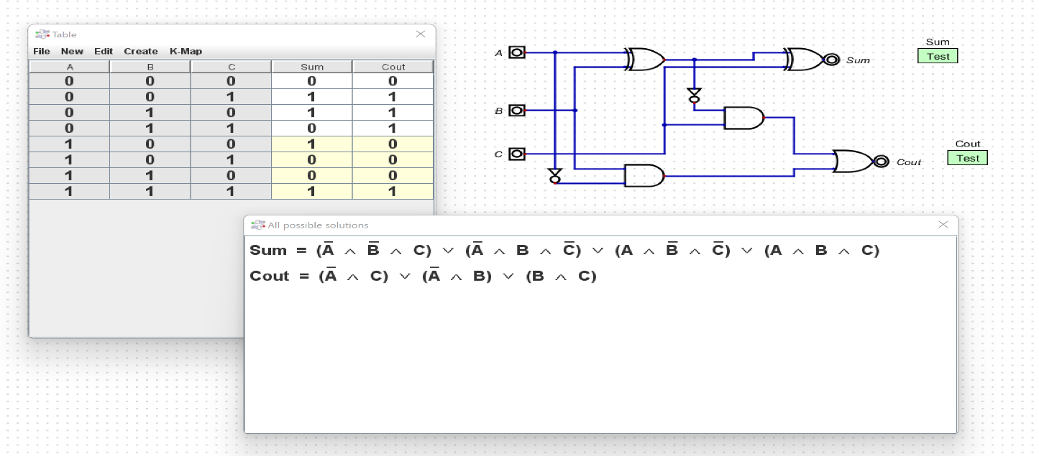

Figure 4: **The digital schematic for the adder/subtractor**

The test results for the **Cout** schematic; in this case, Cout is the previous borrow values.

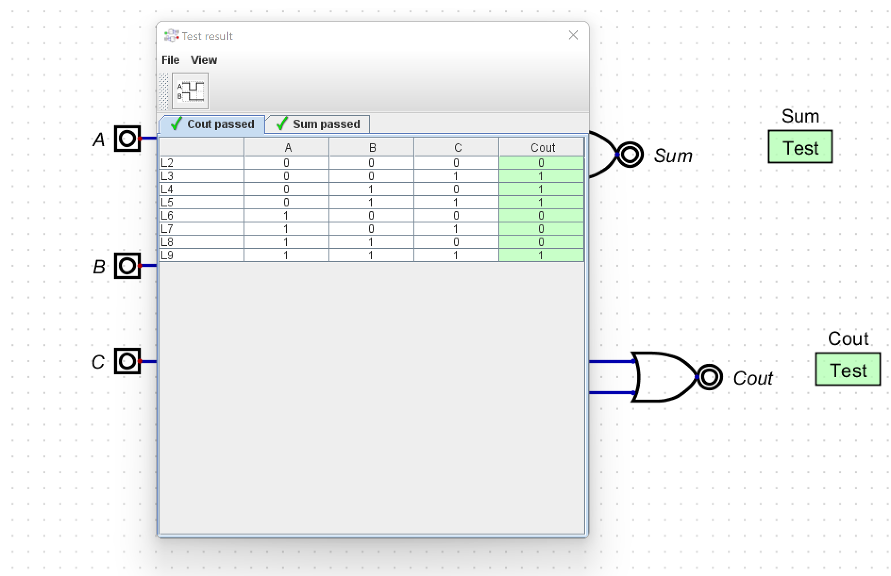

Figure 5: test result of the Subtractor schematic